**Problem Set 1**

**Li Xingxuan 1002189**

**Cohort Exercise 1.2:**

1. Train:
   1. checkDestination(junction_point, train): To check whether the train has reached its destination.
   2. changeTrack(train, track_a, track_b): Change the train from track_a to track_b
   3. stopTrain(junction_point, train): If emergency happens, stop the train at the nearest junction point.
2. Track:
   1. isFull(track, direction): To check whether the track is occupied by another train.

**Cohort Exercise 1.3:**

1. Train:
   1. checkDestination(junction_point, train): To check whether the train has reached its destination.
   2. changeTrack(train, track_a, track_b): Change the train from track_a to track_b
   3. stopTrain(junction_point, train): If emergency happens, stop the train at the nearest junction point.
   4. checkGuage(train, track): To check whether the train fits the guage of the track.
   5. trackNarraw(train, junction_point_a, junction_point_b): Narraow guage trains cannot run longer than the distance between two junction points.
2. Track:
   1. isFull(track, direction): To check whether the track is occupied by another train.

**Cohort Exercise 2:**

1. The code is in the attached folder.

**Cohort Exercise 4:**

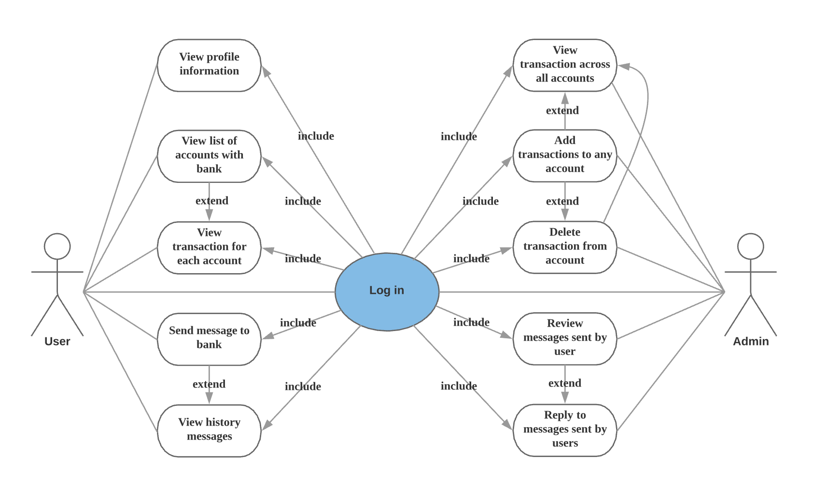

**Cohort Exercise 5**: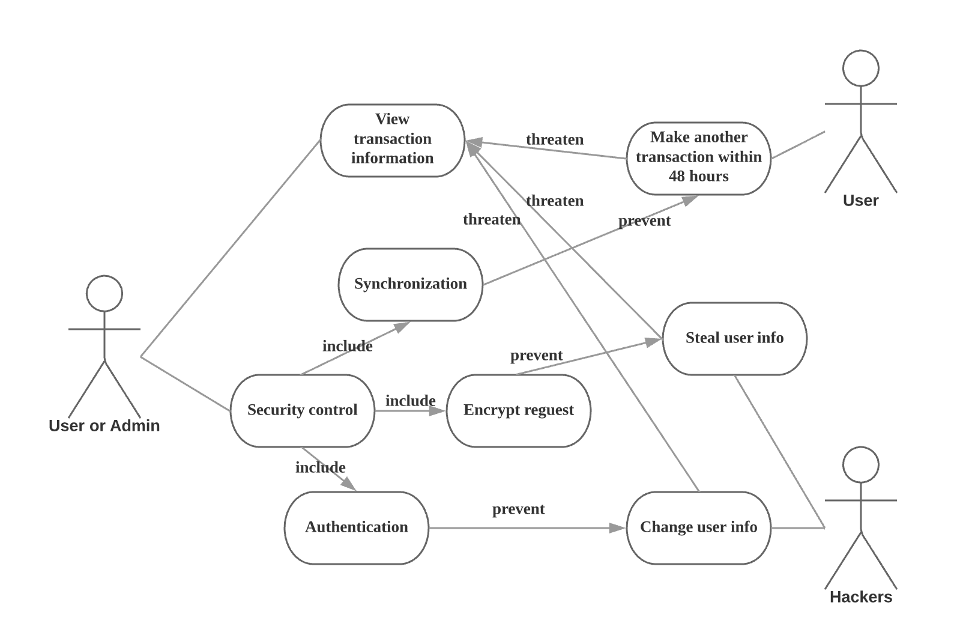

**Cohort Exercise 6:**

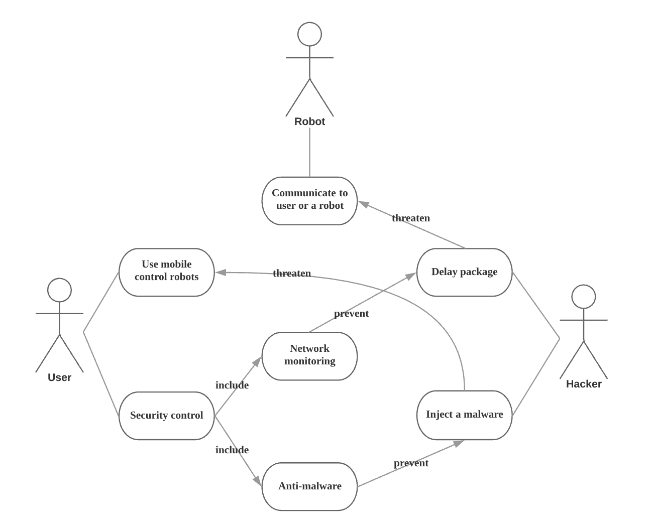

**Cohort Exercise 7:**

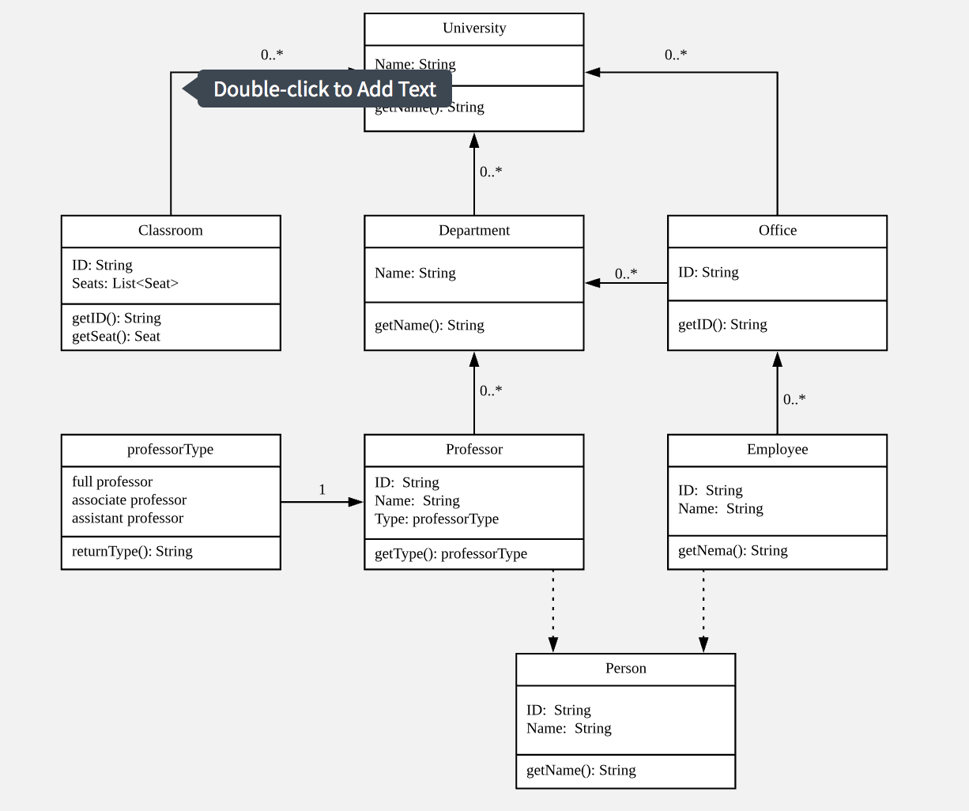

**Cohort Exercise 8:**

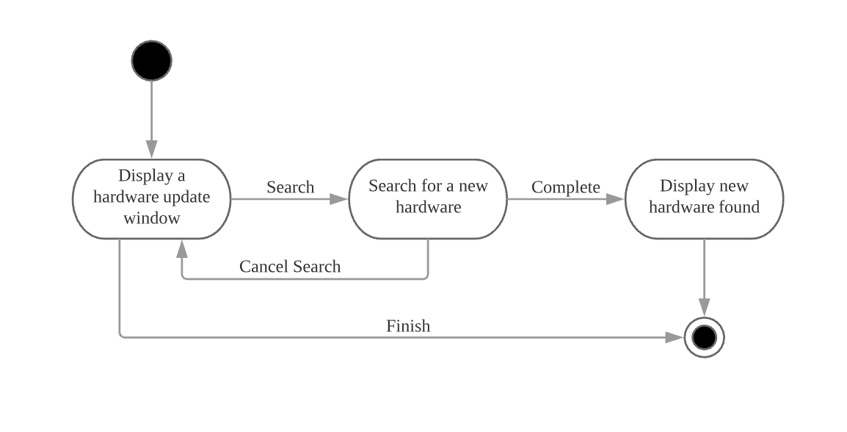

**Cohort Exercise 9:**

